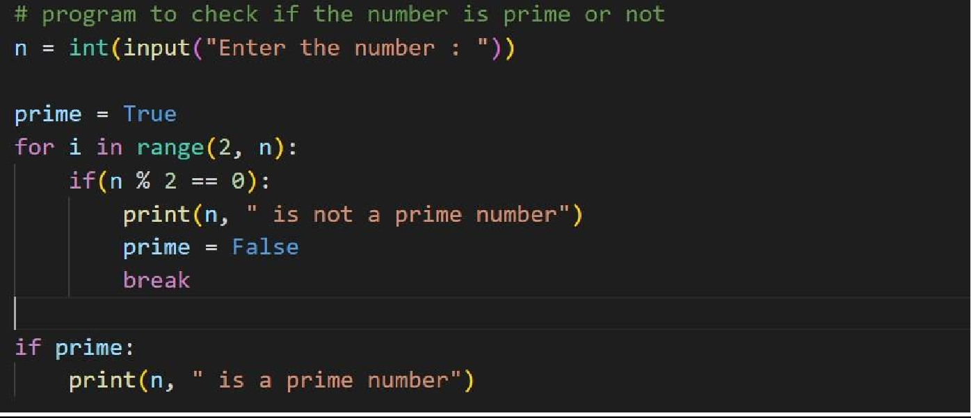Program1:

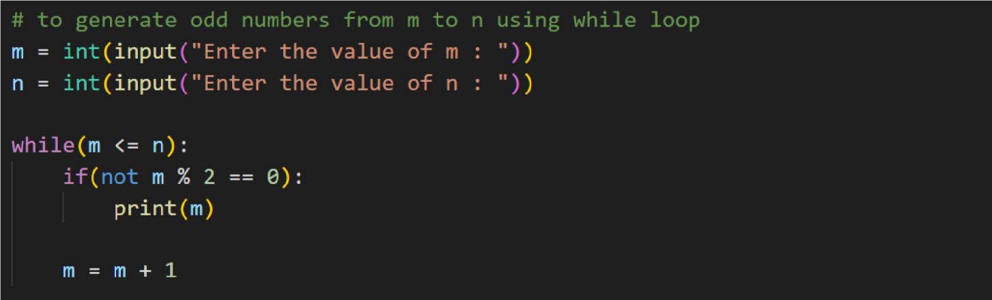Program2:

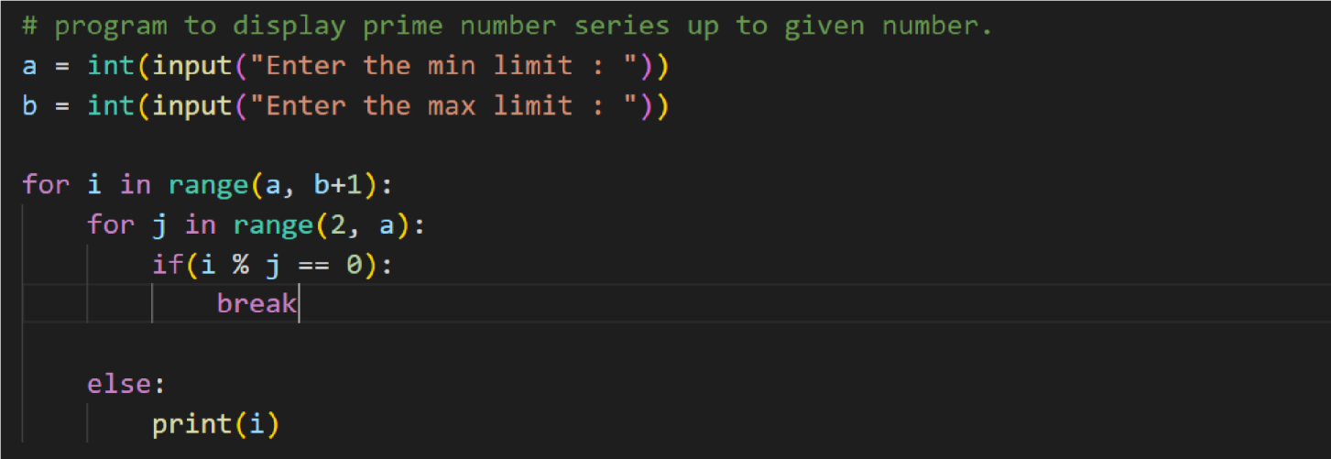Program3:

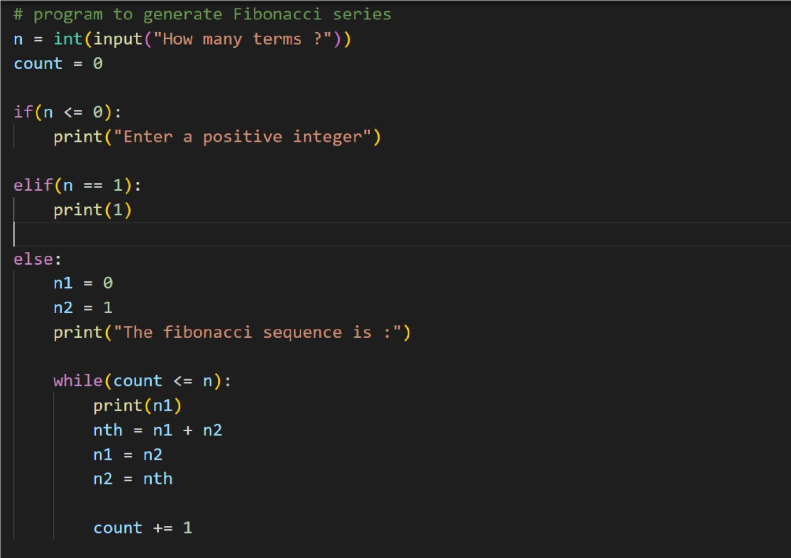Program4:

Submitted by,(TheTeamof)

Name 1

2

3

4